International Rescue Committee
E-Learning Platform & Content Digitizing in Ivory Coast
Request for Information
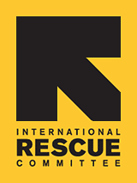
The International Rescue Committee (IRC), a non-profit humanitarian organization, is requesting information from successful and innovative e-learning platform design and digital learning content development suppliers with demonstrated capability to support, enhance and continuously improve the IRC’s program ‘Pro-Jeunes which seeks to promote youth employability and entrepreneurship in Ivory Coast.
We are seeking a professional organization than can support the digitizing of foundational skills building curricula on entrepreneurship and employability for youth in Abidjan and rural areas of Northern Ivory Coast as well as the content delivery through a context suitable e-learning platform that also facilitated interactive mentorship/coaching.
Background
The International Rescue Committee responds to the world’s worst humanitarian crises, helping to restore health, safety, education, economic wellbeing, and power to people devastated by conflict and disaster. Founded in 1933 at the call of Albert Einstein, the IRC is at work in over 40 countries and 26 U.S. cities helping people to survive, reclaim control of their future and strengthen their communities. For more information regarding The IRC visit our website at www.rescue.org

The Pro-Jeunes project will be a project implemented over the course of 5 years in urban Abidjan as well as in rural areas of northern Ivory Coast. The targeted youth will undergo three Phases, namely Phase 1 - foundational skills building, Phase 2 - vocational skills, employment or entrepreneurial skill building through coaching and mentoring depending on the pathway each individual youth is assigned and Phase 3 - a business start-up and employment start phase. Details on the project can be found in Annex A.

RFI Objective
This RFI is intended to gather information that may assist in the development of a future procurement process.
The IRC currently uses tested curricula (see link in Annex A) to train youth in basic employability and entrepreneurship skills through regular in-class training. The Pro-Jeunes project seeks to make this training available through a highly interactive digitized version of the curricula on an e-learning platform which can be used in both urban and rural areas of Ivory Coast with predominantly remote support from coaches via social media, a chat function as well as regular phone calls aided by face-to-face meetings (with a higher ratio in rural than in urban areas to account for connectivity limitations).

IRC Requirements include the provider to deliver the following tasks working in close collaboration with the project’s lead staff on educational e-learning content:
- Content Development Requirements:
IRC seeks a technical partner who can digitize the existing curricula (see Annex A) and with which IRC can explore ways to use a digital platform to enhance content delivery.

- Script writing for digitizing IRC training curricula (see project outline below for links to curricula) in collaboration with dedicated and skilled IRC staff in French
- Developing simple, short and small-sized digital content e.g. videos, quizzes, games, animations based on scripts in French and relevant to the Ivorian context and audience. Ideally this will be done in collaboration with a local production firm to account for context relevance.
- Pilot content with selected stakeholders (private sector partners, youth representatives, IRC staff) to gauge reception, user friendliness, relevance, simplicity, applicability for target group as well as test for any technical glitches
- Adaptations of content based on pilot feedback
- Review and propose use of existing application(s) for basic business management, business simulation games and other suitable enterprise development educational content suitable for French speakers that can be installed in addition to the curriculum content and that are freely available

Timeline:
month 1 – 6: for finalizing first version of content, including adaptations based on feedback received in pilots phase

- Content updating and maintenance:
IRC seeks a partner for the duration of the program who can maintain and update content and the platform during revisions and in response to reported problems
- On-going technical maintenance and bug fixing of CMS with given content
- Update and adjust the digital content after year two using information of the mid-term review conducted by external evaluators, program monitoring information and user data analysis
- Shorter pilot test adjusted content for technical glitches and user friendliness and relevance

Timeline:
month 7 – 54: ongoing technical maintenance
month 30 – 33: review monitoring information and mid-term evaluation of project, adjustment and re-pilot of content

- Technical Requirements:
- License to use a content management model that is suitable for the Ivorian urban and rural environment and suitable for Android devices for the duration of the 5 year project
- Functionality in low-bandwidth locations.
- Mobile/app accessibility – we are interested in exploring responsive HTML design and Android applications as the delivery mechanism
- Potential use on 7” tablets and typical smart phone screen sizes
- Simple user interface intuitive to youth (age 15-24) of varying degrees of educational backgrounds, literacy levels and mobile device experience
- Interactive tools (e.g., discussion, document sharing, calendars, team sites) that allow youth and coaches to collaborate fostering two-way communication.
- Multi-language and localization capabilities, such as English and French language

- Training and Metrics:
- Training of super-users on the CMS and training as trainers of youth users
- A core team of administrators able to support approximately five IRC super users in Ivory Coast in the use of the CMS
- Set-up of user analysis & establishment of monthly analytical reports of user data

- Hardware Management – this requirement may require additional partners
- The provider can propose to use their own tablets or have IRC procure tablets and then pre-load content locally (directly or through partners)
- Pre-loading of content onto tablets (800-1,000) every 6 months for each batch of youth starting the program
- In case of provider tablets, maintenance of devices based on warranty

The IRC prefers to work with a single provider that is capable of delivering on all four of these element directly or in collaboration with partners. At this stage however, IRC will also consider propositions that only address requirements A, B and E or C, D and E together.
Providers need to be able to work in both English and French.
Submission
- Corporate Profile
- Brief corporate history
- Size and location of the organization that will provide services
- Firm’s demonstrated capacity to complete this project
- Brief overview of other company projects where similar services have been provided
- Describe the product(s), recommendations and key factors of project
- Provide estimated timelines details of the project’s creation and implementation
- Include detailed requests of all information needed to complete the project
- Budget Estimate
- Provide an estimated budget for requirements A, B & E as well as C, D & E including main budget lines including the following breakdowns:
  - Cost of tablets if provided
  - Content development
  - Tablet management
  - Rate card of staff hourly / daily rates for digital content development and support
- References
- Provision of current contact information for three (3) clients that have used your organization for similar projects
- Contact information must include name, title and phone number
- Value Add
- Provision of any extra options that are complimentary to or may provide operational and/ or administrative synergy to the core service offering.
- Project Time Line
- Guidance on time estimates for the content development, procurement of tablets, content loading …

Closing Date and Timeframe
The closing date for this Request for Information is Sunday, September 11th 2016 at 20:00:00 hours Eastern Standard Time (EST). Any questions vendors may have regarding the RFI may be directed at Natalia Strigin (natalia.strigin@rescue.org) with a copy to Esta Efstathiadis (esta.efstathiadis@rescue.org) prior to submission time.

Please submit the electronic version in the form of MS Word, Excel or PDF documents, labeled: RFI: IRC E-Learning Platform Pro-Jeunes Ivory Coast to the following the following email addresses:

Natalia Strigin (natalia.strigin@rescue.org)
Clement Lorvao (clement.lorvao@rescue.org)
Cc : Esta Efstathiadis (esta.efstathiadis@rescue.org)

Please limit the document length to 15-pages or less.

Annex A – Project Details

The Pro-Jeunes project is supposed to start in October 2016 followed by a 4-6 month inception phase during which the learning content needs to be reviewed, adapted, digitized, uploaded and tested before being used with the first batch of youth. The project will end in September 2021.

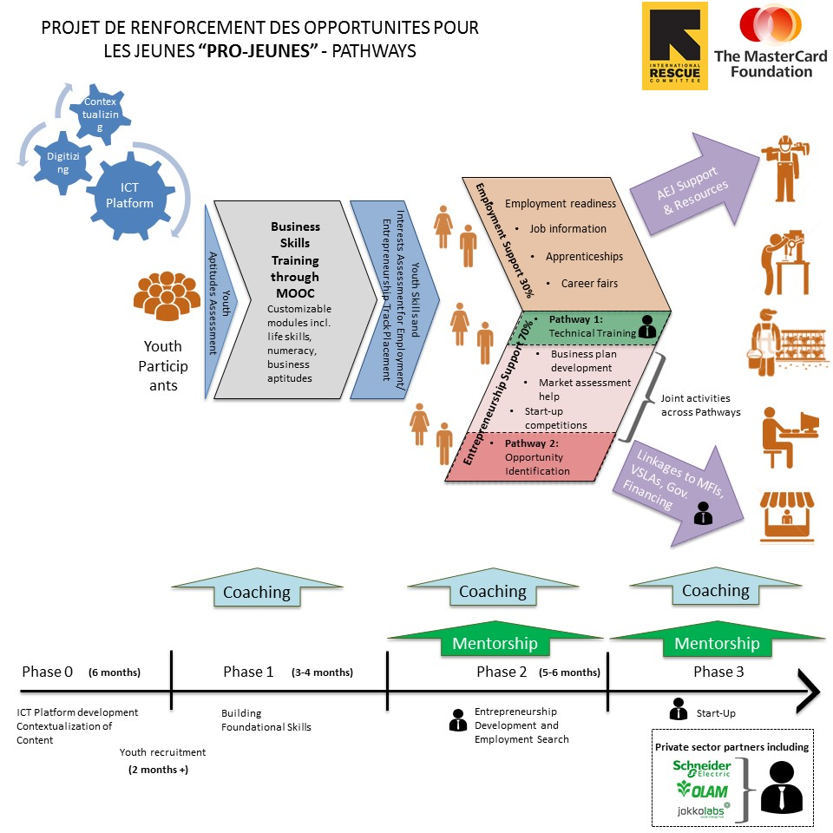

Learning Content:

The e-learning platform will provide the learning material for the foundational skills training on the basis of IRC’s LearnToEarn Curriculum (existing in English and French). The curriculum includes skills on business planning and start-up, personal and business budget management, personal and business goal setting, savings as well as life skills. It is not a formal/academic curriculum but rather geared towards youth to extend practical skills quickly. Their participation in the foundational skills training will be acknowledged by an informal certificate. Throughout the project IRC will determine with relevant ministries in Ivory Coast if the training can be officially certified.
Secondly, content on village savings and loan associations will be digitized as repetitions to actual in person training of youth to establish VSLAs which is being provided on the basis of IRC’s VSLA training curriculum.
In addition, the tablets used will provide basic free apps for the management of small businesses, job application management and personal goal and budget management.

Target Audience:

By the end of the 5 years 9,000 youth between 15-24 year of age (5,400 female, 3,600 male) will have participated in the project. The youth will be targeted amongst vulnerable and unemployed/underemployed youth in rural areas around Northern Ivory Coast (around Kohrogo) and in urban Abidjan. The youth will undergo the program in batched during which they will be supported by 18-20 coaches.
The targeted youth will differ significantly in their background. Following some categories will be described to get a better sense of the scope of youth to be targeted.

Age groups: 15 – 18, 19 – 22, 23-24
Education Levels: from primary or below with very limited reading, writing and calculus skills to university graduates highly skilled in their academic field, school ages youth must be long-term out-of-school youth or those graduated without intent to continue formal education at this point
Work experience: from participants with no or very limited working experience either due to age or engagement in formal education up to university level to participants with extensive work experience in one or more fields having worked in family businesses, needing to support their families throughout periods of their adolescence
ICT Experience: from youth with very limited exposure to ICT (max having used a basic mobile phone) to youth even having been educated in IT. There are likely to be significant differences in male and female exposure to ICT as well since technology/gadgets in households are often monopolized by male members.
Disabilities: Some youth may present physical disabilities, including being deaf or blind.
Women: 60% of the youth targeted will be women who generally face more limitations due to limited mobility, less time and flexibility in timing dues to household chores, lower educational levels as well as having to overcome social stigma and norms limiting in terms of the types of industries and jobs considered appropriate for them.

Learning Environment:

The project intends to teach the foundational skills as much as possible remotely through an e-learning platform. This method will be accompanied by coaches supporting youth remotely or when and if needed in person. Coaches are skilled educational staff with backgrounds in teaching, facilitation, social work and training. Coaches will be trained on the platform and content of the foundational skills training as well as the objectives of their coaching. They will be supervised by the coach manager reviewing their performance on a bi-weekly basis and providing guidance and support to the coaches in their day-to-day job.

Interactions between youth and coaches are anticipated to be more frequent in urban areas where the infrastructure allows for internet and phone connectivity. The youth will be in touch at least every 2 weeks with their coaches. To be in contact youth will be using the tablets/e-learning platform for the most part. Using the internet (either through Wifi at points of access in urban areas, 3G where that is difficult for youth to access the wifi points and via dongles in rural areas during planned sessions). This will allow uploading of user data, test data as well as exchange amongst peer groups via the platform chat or social media such as whatsapp or facebook. Similarly charging of tablets will take place at home, access locations and classrooms depending on the conditions.

In rural areas coaching will be held largely in person with youth using the e-learning under supervision by the coaches. This will address some of the infrastructure issues, i.e. lack of connectivity and electricity in rural areas as well as gaps in literacy and ICT user experience which are more likely to occur in rural areas.

Youth will also be grouped to facilitate peer-support and learning as well as to provide easier platforms for communication between coaches and youth as well as mentors (industry specific role models supporting youth but less intensively than coaches).

The point in using an e-learning platform is to allow for sufficient flexibility for youth to learn when they can which is especially important for women. Youth will have a total of 3-4 months to get through the curriculum at their own pace. On average this would require 1.5 hours of work on the platform per day during workdays for 3 months. This is however adaptable to the needs. For example in rural areas, sessions will be pulled together to be taught in one day while youth in urban areas can go at their own pace. The curriculum builds on each other so there is an order to the modules. However, given the differences in skills and experience level of the youth to be targeted, content can be accessed at youth’s individual preference. Each learning component will be accompanied by some form of a test of knowledge to reassure the youth that he/she has understood the content or if not can revisit the session.

Users will be trained on the use of the tablet and content prior to starting the foundational skills course so they are confident using it. In case of usage problems coaches will support youth remotely or in person. In case of potential technical problems the issue will be cascaded up through a chain of support starting with the coach, moving up to the project staff and IRC IT staff. Hardware issues will need to be addressed by the seller while content bugs need to be addressed by the service provider.

Technology:

IRC is looking to use tablets with
- an Android operating system
- 7” screens
- if feasible, sim-card enabled tablets will be preferred to allow for regular communication between youth and coaches where infrastructure allows
- long battery life
- either SD enabled or internal memory between 8 & 16 GB (SD cards to be provided to coaches for updating of content if needed)
- cover case & screen foil for protection

The tablets will be bought by youth at 15USD with the rest of the costs subsidies by the program. As such there won’t be any limitations put in place on the tablet. The program will not replace stolen or broken tablets should such instances occur, loaner tablets or shared schemes will be provided to youth to continue the foundational skills building. Wiping content remotely will not be necessary.
The maintenance of the tablet will be the responsibility of the youth and not the program as they will take possession of the equipment from the start of the program.

