# **GENDER PAY GAP REPORT – For 5 April 2024**

## **Background**

IRC UK has calculated its gender pay gap for April 2024 using the standard methodologies in the [Equality Act 2010 (Gender Pay Gap Information) Regulations 2017.](https://www.gov.uk/government/publications/gender-pay-gap-reporting-guidance-for-employers/making-your-calculations) A bonus pay gap has not been calculated as these are rarely awarded at IRC UK, even on a discretionary basis.

## **Findings**

**Workforce**

This gender pay gap report is for the **snapshot date of 5 April 2024**. At this time, IRC UK had **263 employees,** of which **196 were women and 67 were men**.

**Pay quartiles**

This table shows our workforce divided into four equal-sized groups based on hourly pay rate.

| **Pay quartiles by gender** | | | |
| --- | --- | --- | --- |
| **Quartile** | **Men** | **Women** | **Description** |
| Lower | 15% | 85% | Includes all employees whose standard hourly rate places them at or below the lower quartile |
| Middle Lower | 23% | 77% | Includes all employees whose standard hourly rate places them above the lower quartile but at or below the median |
| Middle upper | 27% | 73% | Includes all employees whose standard hourly rate places them above the median but at or below the upper quartile |
| Upper | 36% | 64% | Includes all employees whose standard hourly rate places them above the upper quartile |

A quartile is one of four equally sized groups created when you divide a selection of numbers that are in ascending order into four. The "lower quartile" is the lowest group. The "upper quartile" is the highest group.

**Mean and Median Gender Pay Gap**

* The **mean gender pay gap** for IRC UK was **12%** on mean hourly salaries (£33.82 for men and £29.74 for women).
* The **median gender pay gap** for IRC UK was **14%** on median hourly salaries (£32.73 for men and £28.13 for women)

The mean hourly pay rate is the average, and the median hourly pay rate is the central value when salaries are organised from lowest to highest. The median gender pay gap is generally more reliable, as it reduces the impact of very high or low salaries.

A positive pay gap means that the mean or median hourly pay is higher for men than women. A negative pay gap means that the mean or median hourly pay is higher for women than men.

Since the last measurement on 5th April 2023, the mean gender pay gap has increased from 8% to 12% and the median gender pay gap has increased from 12% to 14%.

IRC UK is confident that our gender pay gap is not because we pay men and women differently for the same or equivalent work. Instead, the gender pay gap appears to stem from men and women working in different roles that have different salaries.

We are committed to equal opportunities and treatment for all employees, regardless of sex, race, religion or belief, age, marriage or civil partnership, pregnancy/maternity, sexual orientation, gender reassignment or disability. We have a clear policy of paying employees equally for the same or equivalent work, regardless of their sex (or anything else listed above).

We:

* carry out regular pay and benefits audits;
* evaluate job roles and pay grades to ensure fairness.

IRC UK's workforce is 75% women and 25% men, therefore relatively small changes in the distribution of men across the different pay quartiles can have a significant impact on our gender pay gap. We see fluctuations in our median pay gap month by month and year by year.

## 

## **Compared with other organisations**

According to the 2024 Office for National Statistics (ONS) Annual Survey of Hours and Earnings (ASHE)[1] the estimated median gender pay gap for all employees was 13.1%.

2,765 organisations reported their gender pay gap on the GOV.UK website[2] for 5th April 2024, when the data for this report was collected. According to the reported figures, of the 86 non-profit organisations that fall into the same classification codes as IRC UK[3], the median gender pay gap is 2.9%, and the mean gender pay gap is 6.7%.

IRC UK has a higher mean and median gender gap compared to the Pay Club (9.9%) and GOVUK (6.7%). IRC UK also has a slightly higher median pay gap than ONS, which only publishes the median pay gap.

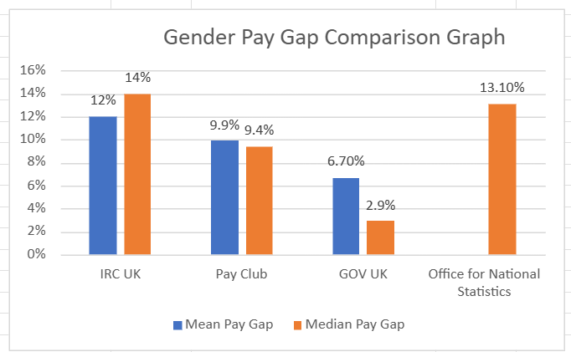

## **Addressing IRC UK’s gender pay differences**

To understand better what drives our gender pay gap, we monitor salary and promotion trends throughout the year and conduct regular pay benchmarking. Salary scales are updated in line with results and are accessible on our intranet for all staff to review.

We aim to be as transparent as possible regarding the pay range for roles we advertise. We ensure selection pools and panels are gender-balanced and guide managers outside the UK who wish to recruit in the UK to ensure this is standardised.

We regularly provide refresher training for managers and staff members involved in pay reviews in hiring and promotions.

We are committed to encouraging more flexibility in senior-level roles so that women and men can take these on regardless of their caring responsibilities. We offer enhanced paternity/co-parental leave from the first day of employment to make it easier for both parents to share childcaring responsibilities and review other family-friendly policies regularly to the same end.

1. <https://www.ons.gov.uk/employmentandlabourmarket/peopleinwork/earningsandworkinghours/bulletins/genderpaygapintheuk/2024>

   <https://gender-pay-gap.service.gov.uk/>
2. SIC Codes 85600,86900,88990, and 94990
3.